Mass immigration ‘Big Australia’ policy is destroying the West
By Unconventional Economist in Australian Economy
at 12:15 am on January 10, 2018 | 92 comments
By Leith van Onselen
Ceridwen Spark, a vice-chancellor’s senior research fellow in global, urban and social studies at RMIT University, has penned an article in Fairfax lamenting the destruction of Melbourne’s West as rapid immigration-fueled population growth overruns the area’s economic and social infrastructure:
So how are we to understand all this rabble-rousing in the western suburbs?… [This] area of Melbourne… has grown more quickly than anyone anticipated, let alone planned.
Bursting at the seams 20 years ago, Melbourne bulged west. Werribee, despite being associated with our collective waste, has a long history and a village quality. But the city spilt westwards in more unruly ways, giving rise to suburbs such as Tarneit, Manor Lakes and Truganina. According to figures from the Australian Bureau of Statistics, Melbourne’s west had the largest growth in Greater Melbourne, with an increase of 20,900 people between 2014 and 2015.
Regrettably, however, infrastructure does not match the needs of the people who live in these suburbs. The trains are too full, bus routes are rare or non-existent, and schools overflow as soon as they are built. The privileges that inhabitants of the eastern suburbs take for granted – treed bike paths, protected riversides, new trams and thriving public schools – are largely absent from these maligned outposts, long associated with Melbourne’s industry and refuse.
All this boils down to one thing: like the places they come from, the people who live in Melbourne’s outer west are not taken seriously. Occupying safe Labor seats, they are ignored and discounted by both major political parties.
By and large, the city’s powerbrokers still come from Melbourne’s wealthier eastern suburbs and attend the universities there, not the one with campuses in Footscray or Werribee…
Similar sentiments were expressed last year by former Labor leader and Western Sydney resident, Mark Latham, who penned a call to arms against the immigration ponzi destroying living standards in the West:
Instead of cutting immigration numbers to bring down housing demand and housing prices, Liberal and Labor are focusing on just one side of the housing market: increased supply.
They want to flood the Sydney basin with wall-to-wall urbanisation.
They are building a vast metropolis, extending to Appin in the southwest and abutting the Blue Mountains in the west.
Most of the growth is concentrated in a new residential corridor between Penrith and Camden — building a city the size of Canberra along the spine of the narrow, two-lane Northern Rd.
This is the snake oil of our time: the fantastic notion that in a city already heavily congested, we can swamp Western Sydney with new arrivals and new suburbs and somehow the magic of “improved urban planning” will produce a metropolitan nirvana…
It will never be a liveable city as long as massive immigration numbers overwhelm our suburbs and clog up our roads…
The business lobbyists, economists and MPs pushing for big migration numbers do so safe in the knowledge that overcrowding and congestion will never affect the gentrified, inner-city boroughs in which they live…
We need an Australia-first migration program, designed for the benefit of the people who live here, not those wanting to come here.
For Western Sydney, this means abandoning Big Australia and limiting population growth into the region.
The Western regions in both our major cities have a lot in common. They are both the epicentre of the working class. And they have both become the prime dumping grounds for the federal government’s mass immigration ‘Big Australia’ program.
We already know that both Sydney and Melbourne have experienced insane levels of population growth over the past 12 years:
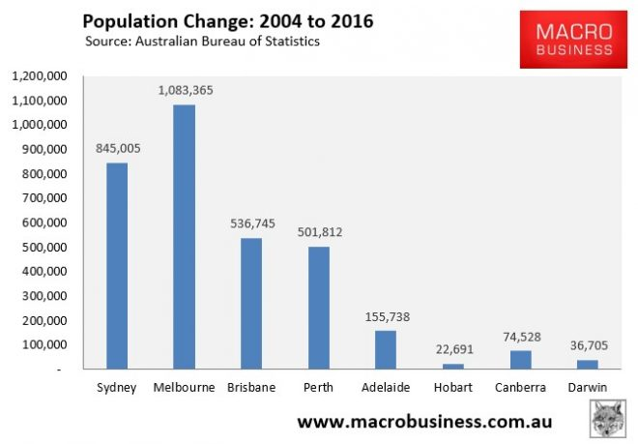
Driven primarily by insane levels of net overseas migration:
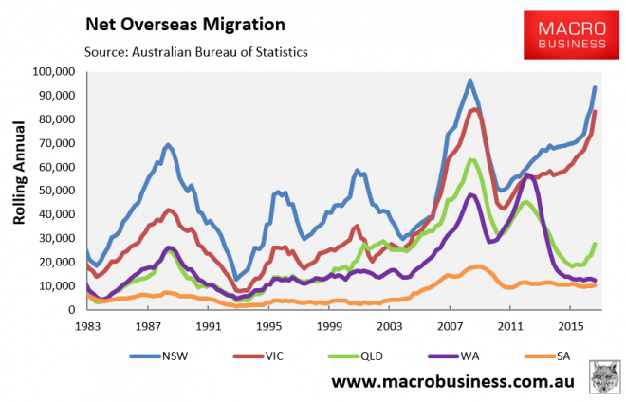
And we know from ABS’ population data that most of this growth has occurred in the Western regions of both major cities:
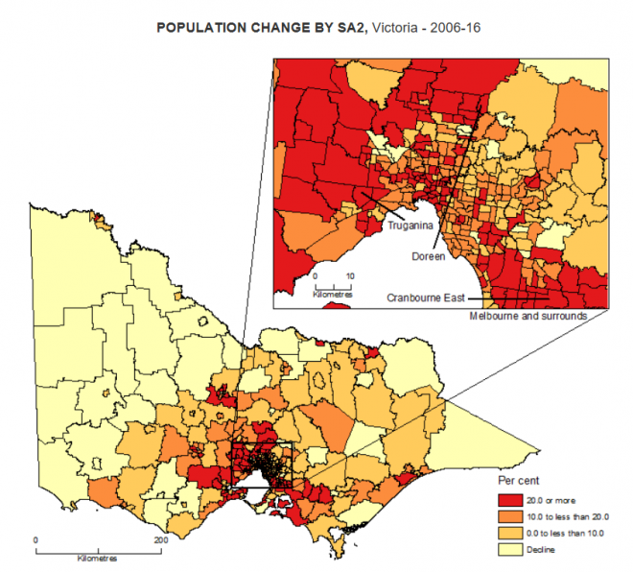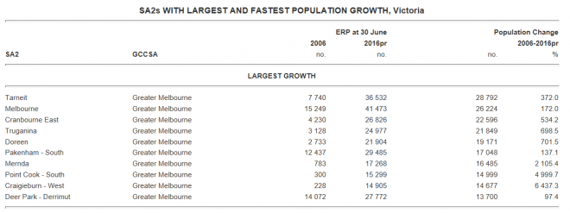

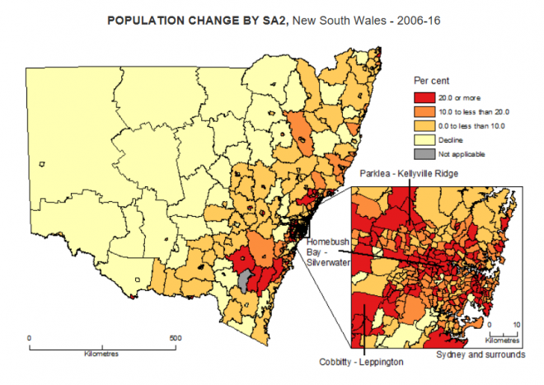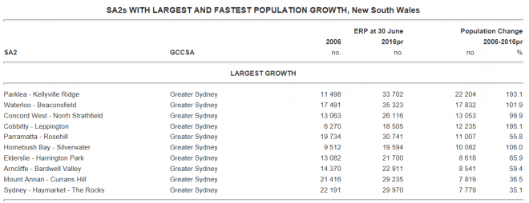
I’ve said it before and I will say it again: Sydney’s and Melbourne’s population pressures are a direct result of the federal government’s mass immigration program, which is supported by our elites living in their sheltered inner suburbs. This ‘Big Australia’ program has committed to an intake of more than 200,000 permanent migrants a year ad infinitum:
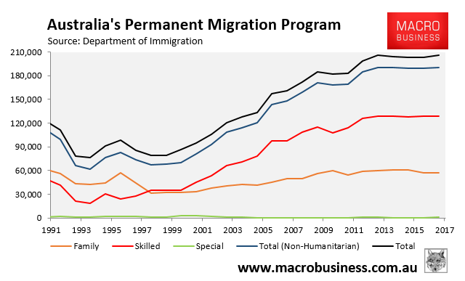
All these extra migrants – which overwhelmingly choose to settle in Sydney and Melbourne, and mostly flood the West – need to be housed and need infrastructure. So as long as this mass immigration madness continues – supported by the Coalition, Labor and The Greens – the Western Suburbs will continue to be crush-loaded. It’s that simple.
My advice to residents of the West is to:
- lobby your state and federal members of parliament to slash Australia’s immigration intake; and
- make sure that you vote Sustainable Australia at the next election and put the three major parties last on your ballot paper.
It’s the only way that your voice will be heard by our tin-ear politicians intent on destroying your living standards

https://www.macrobusiness.com.au/2018/01/mass-immigration-big-australia-policy-destroying-west/

